Experiment -5

Name -Pranav Sandeep Raikar Batch -B

Div -D10A Roll no-43

(i) Write a shell script to perform arithmetic operations.

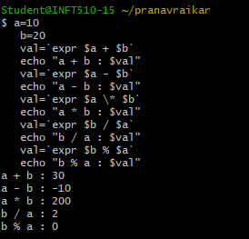

ii) Write a shell script to calculate simple interest.

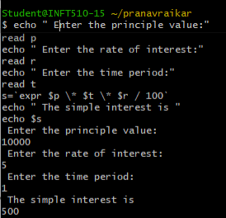

(iii) Write a shell script to determine largest among three integer numbers.

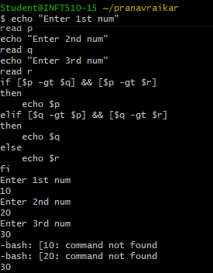

(iv) Write a shell script to determine a given year is leap year or not.

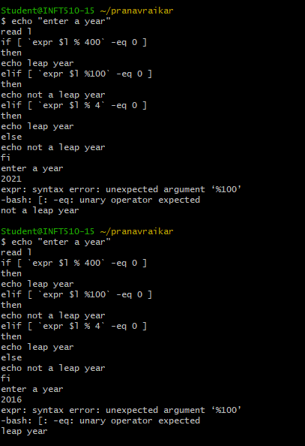

(v) Write a shell script to print the multiplication table of a given number using a while statement.

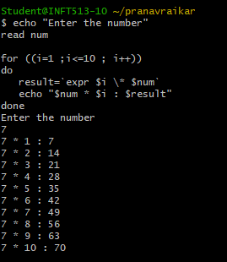

(vi) Write a shell script to compare two strings.

